Comparative study of
AI, ML, DL, Gen AI & Agentic AI

Contributed by:

  - Srishti - 2024UCA1923
  - Poorva Tehlan - 2024UCA1891
  - Shriya Jindal - 2024UCA1889
  - Kehkasha - 2024UCA1895
  - Iba Shibli - 2024UCA1941

Introduction
Artificial Intelligence (AI) has evolved from rule-based systems to data-driven learning models and, more recently, to generative and autonomous systems. Machine Learning (ML) enabled systems to learn from data, while Deep Learning (DL) extended this capability through multi-layer neural networks. Generative AI (Gen AI) marked a major shift by enabling machines to create new content rather than only predict outcomes. Building on this, Agentic AI represents an emerging paradigm focused on goal-directed reasoning and autonomous action.
Understanding how these paradigms differ and how they build upon one another is essential in the context of rapid technological advancement.

Objectives of this report

  - To clearly define and differentiate Artificial Intelligence, Machine Learning, Deep Learning, Generative AI, and Agentic AI.
  - To analyze the historical progression and conceptual evolution of these paradigms.
  - To compare their working principles, capabilities, and limitations.
  - To highlight the shift from predictive and discriminative models to generative and autonomous systems.
  - To provide a structured framework for understanding modern and emerging AI technologies.

1. Artificial Intelligence (AI)

1.1 Introduction – Why Artificial Intelligence Came Into Being
The field emerged from a fundamental desire to understand if the cognitive processes defining humanity, reasoning, learning, and perception, could be decoupled from biological wetware and reconstructed in silicon.

1.1.1 The Philosophical and Mathematical Foundations
The foundational question was posed most famously by Alan Turing in his seminal 1950 paper, Computing Machinery and Intelligence. Turing bypassed the semantic quagmire of defining "thinking" by proposing a pragmatic, operational test: the Imitation Game.
If a machine could exhibit behavior indistinguishable from a human, Turing argued, it deserved the attribution of intelligence.
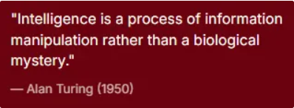
Concurrent with Turing’s work, the field of cybernetics, led by Norbert Wiener, established that control and stability in systems, whether mechanical or biological, relied on feedback loops. Wiener’s work in 1948 suggested that the "goal-seeking" behavior observed in living organisms could be mathematically modeled in machines. This was a radical departure from the deterministic clockwork view of mechanics; it introduced the concept of agents that could adapt to their environment to maintain homeostasis or achieve objectives.

1.1.2 The Neurophysiological Convergence
The third pillar was the emerging understanding of the brain as an electrical network. In 1943, Warren Sturgis McCulloch and Walter Pitts published a landmark paper modeling neurons as logical units. They demonstrated that a network of binary "on/off" neurons could, in principle, compute any logical function. This was the bridge between biology and computation: if the brain is a network of logical gates, and computers are built of logical gates, then the brain is, in essence, a biological computer.

1.2 What Problem Was It Trying to Solve?
At its inception, Artificial Intelligence sought to solve a problem that was simultaneously engineering-focused and deeply existential: the automation of general-purpose cognitive labor.

1.2.1 The Dartmouth Ambition
The specific problem statement was crystallized during the Dartmouth Summer Research Project of 1956, universally recognized as the field's founding event. The organizers, John McCarthy, Marvin Minsky, Nathaniel Rochester, and Claude Shannon, did not aim for mere calculation, which computers had already mastered. They aimed for reasoning. Their proposal explicitly stated the hypothesis that "every aspect of learning or any other feature of intelligence can in principle be so precisely described that a machine can be made to simulate it."

The core problems they identified for solution included:
- Natural Language Understanding: Moving beyond code to semantic comprehension of human speech and text.
- Abstract Concept Formation: Enabling machines to use sensory data to form categories and generalizations.
- Self-Improvement: Creating systems that could learn from experience and alter their own code to perform better over time.
- Solving Ill-Structured Problems: Addressing tasks where the rules are not clear-cut, unlike arithmetic, such as strategic planning or creative synthesis.

1.2.2 The Automation of Expertise

Beyond the theoretical, the practical problem AI sought to solve was the "knowledge bottleneck" in society. As industrial systems became more complex, the demand for human expertise in medicine, engineering, and logistics outstripped supply. AI promised a solution: if expert decision-making could be captured in a system, it could be replicated infinitely at near-zero marginal cost. The goal was to detach intelligence from the scarce resource of the human brain and turn it into a scalable industrial asset.
1.3 Historical Evolution

1.3.1 The Era of Symbolic Optimism (1956–1974)
Following the Dartmouth conference, the field entered a period of extraordinary productivity. The dominant paradigm was Symbolic AI, which posited that intelligence could be achieved by manipulating symbols (representing concepts) according to formal logical rules.

- The Logic Theorist (1956): Allen Newell and Herbert Simon developed the first program to mimic human reasoning. It proved 38 theorems from Principia Mathematica, finding proofs more elegant than those of Russell and Whitehead. This demonstrated that creativity and logic were computational processes.

- The General Problem Solver (1959): This program attempted to separate general reasoning strategies from specific domain knowledge, simulating how humans solve problems by setting goals and reducing the distance to them.

- Early Gaming Success: Arthur Samuel’s checkers program (1952-1955) was a pioneer in machine learning, using self-play to improve until it could challenge amateur humans.
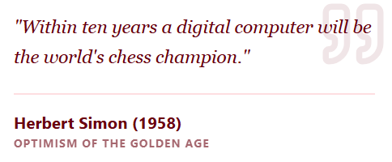

1.3.2 The First AI Winter (1974–1980)
The optimism of the 1960s crashed into the hard walls of computational complexity and institutional skepticism in the early 1970s.

- The Lighthill Report and Political Skepticism
In 1973, the UK’s Science Research Council commissioned Sir James Lighthill to evaluate the state of AI. His report was devastating. Lighthill argued that AI techniques worked only on "toy" problems and failed completely when scaled to real-world complexity due to the Combinatorial Explosion which is the exponential growth of search space in complex problems.

Historical analysis suggests the report was not purely scientific but also political. It was a manifestation of the "Tobacco Strategy" where skepticism is weaponized to justify defunding. Lighthill’s classification of AI as a "bridge" activity that had failed to connect its foundations to practical applications provided the cover for the British government to dismantle its AI research infrastructure, causing a massive brain drain.

- DARPA’s Management Pivot
Simultaneously in the US, the "Heilmeier Catechism" transformed DARPA funding. The visionary, open-ended funding of the Licklider era was replaced by strict milestone-driven management. The Speech Understanding Research (SUR) project became a casualty of this shift. When the project failed to meet arbitrary quantitative benchmarks for vocabulary size and processing speed, it was cancelled.

1.3.3 The Expert Systems Renaissance (1980–1987)

AI was resurrected in the 1980s by narrowing its scope. Instead of trying to simulate a whole human brain (General AI), researchers focused on simulating a specialist (Expert Systems).

Commercial Success: Systems like XCON (for configuring DEC computers) saved corporations millions, proving AI had commercial value.

MYCIN: As a diagnostic tool for blood infections, MYCIN outperformed human specialists in controlled trials, validating the "knowledge-based" approach where thousands of rules encoded expert intuition.

This success triggered a boom. Corporations poured billions into AI departments, and Japan launched the massive "Fifth Generation Computer Systems" project, terrifying the West into a funding race.

1.3.4 The Second AI Winter (1987–1993)
The boom proved unsustainable. The "Second Winter" was triggered by the collapse of the specialized hardware market and the realization of the maintenance burden of expert systems.
- The LISP Machine Collapse
Companies like Symbolics and Lisp Machines Inc. had built an industry around specialized computers designed to run Lisp code. They generated roughly a billion dollars in revenue. However, the "Attack of the Killer Micros" — commoditized PCs and workstations from Sun and Intel — undercut them. Moore’s Law made cheap, general-purpose chips faster than expensive, specialized AI chips. By the late 80s, the LISP machine market evaporated, bankrupting the leaders of the AI industry.
- The Brittleness of Rules
Simultaneously, companies realized that expert systems were "brittle." They could not learn, required expensive manual updating (the "knowledge acquisition bottleneck"), and failed catastrophically when presented with edge cases. The promise of easy automation turned into a nightmare of maintenance.

1.4 Core Concepts & Working Principle

The classical AI paradigm, which dominated until the rise of modern machine learning, was built on Symbolic AI. Its working principle is fundamentally different from the statistical learning used today.
1.4.1 Knowledge Representation
If a machine is to reason, it must have an internal model of the world. Symbolic AI represents this model explicitly.

- Facts and Rules: Knowledge is stored as discrete symbols. Human(Socrates) is a fact. All Humans → Mortal is a rule.
- Semantic Networks: Concepts are nodes in a graph, connected by relationships (e.g., "is-a", "part-of"). This allows for inheritance; if a system knows "Birds can fly" and "Sparrow is a bird," it infers "Sparrow can fly" without explicit instruction.
- Frames: Complex objects are represented as "frames" with "slots" for attributes, allowing the system to have expectations about objects (e.g., a "Room" frame expects walls, a floor, and a ceiling).

1.4.2 The Inference Engine
Feature | Forward Chaining | Backward Chaining
Direction | Data → Goal | Goal → Data
Trigger | Arrival of new facts | Query/Question asked by user
Best Use Case | Monitoring, Configuration (XCON) | Diagnosis (MYCIN), Debugging
Efficiency | Can generate irrelevant conclusions | Focused only on relevant data

1.4.3 Search and Planning
- State Space Search: The system explores different paths from the initial state to the goal state.

- Heuristics: Because the search space is often too big (Combinatorial Explosion), AI uses "rules of thumb" (heuristics) to prioritize likely paths. The A algorithm* is a classic example, calculating the cost to reach a node plus the estimated cost to the goal.

- STRIPS Planning: Used in robotics (like Shakey), this formalism defines actions by their "Preconditions" (what must be true to act) and "Effects" (how the world changes). This allows a robot to plan a sequence: "To move block A, I must first clear block B."

1.5 Limitations That Led to the Next Paradigm
The shift from Symbolic AI to the current era of Machine Learning and Neural Networks was driven by fundamental barriers that symbolic logic could not breach.

1.5.1 The Knowledge Acquisition Bottleneck
Symbolic systems required human experts to explicitly articulate their rules. This was slow, expensive, and often impossible. Experts often know how to do something (tacit knowledge) but cannot verbally explain the rules (e.g., "how do you recognize your mother's face?"). You cannot write "if-then" rules for intuition.

1.5.2 Brittleness and Handling Uncertainty
Symbolic logic is binary: True or False. The real world is probabilistic and ambiguous.

1.5.3 Moravec’s Paradox
Perhaps the most profound realization was Moravec’s Paradox, formulated in the 1980s. It observed a counter-intuitive reality:

Hard is Easy: High-level reasoning (chess, algebra), which requires conscious effort for humans, requires very little computation for machines.

Easy is Hard: Low-level sensorimotor skills (walking, recognizing faces), which are effortless for humans, require enormous computational resources for machines.

2. Machine Learning (ML)

2.1 Introduction – Why Machine Learning Came Into Being
Machine Learning (ML) emerged as the second major paradigm in the quest for artificial intelligence, following the limitations of Symbolic AI. It represented a fundamental philosophical inversion , rather than attempting to encode human knowledge into logic-based rules (deduction), researchers sought to build systems that could extract knowledge directly from raw data (induction).

2.1.1 The Shift from Logic to Statistics
The "Knowledge Acquisition Bottleneck" that strangled the Expert Systems era revealed a critical flaw in classical AI, human experts often possess tacit knowledge they cannot articulate. A doctor can diagnose a tumor but cannot write a precise "if-then" code for how they recognize the texture in an X-ray.
Machine Learning came into being to solve Polanyi’s Paradox, formulated by Michael Polanyi in 1966 , "We can know more than we can tell." If we cannot tell the computer the rules, we must design algorithms that allow the computer to discover the rules by analyzing statistical correlations in vast datasets.
2.2 What Problem Was It Trying to Solve?
Machine Learning sought to address the limitations of rule-based systems in handling the "messiness" of the real world.
2.2.1 The Problem of High-Dimensional Variance
Classical programming works well for low-variance, clear-cut logic (e.g., calculating taxes). It fails catastrophically in high-variance domains like perception.
- Computer Vision: Trying to define a "cat" using geometric rules is impossible because cats vary in color, pose, size, and lighting.
- Natural Language: Human speech is filled with slang, sarcasm, and context-dependence that rigid grammar rules cannot capture.
The problem ML solved was how to create adaptive systems that could handle infinite variations without needing infinite lines of code.
2.2.2 Scalability of Decision Making
With the advent of the World Wide Web, the volume of digital information exploded. It became physically impossible for humans to manually categorize emails, curate search results, or detect credit card fraud at the scale of the global economy. ML provided the mechanism to automate decision-making where the "logic" is derived dynamically from the data stream itself.
2.3 Historical Evolution
2.3.1 The Connectionist Origins (1950s–1960s)
Machine Learning shares its roots with the earliest days of AI, though it was often sidelined by the Symbolic camp.
- The Perceptron (1958): Frank Rosenblatt built the Mark I Perceptron, the first hardware-based neural network. It could learn to classify simple visual inputs. The New York Times reported it as "the embryo of an electronic computer that [the Navy] expects will be able to walk, talk, see, write, reproduce itself and be conscious of its existence."
- Arthur Samuel’s Checkers (1959): Samuel wrote a program that played thousands of games against itself, learning which board states led to victory. He coined the term "Machine Learning," defining it as the "field of study that gives computers the ability to learn without being explicitly programmed."
2.3.2 The Statistical Renaissance (1990s)
Following the "AI Winter," ML re-emerged in the 1990s not as a quest for simulating consciousness, but as a rigorous mathematical discipline grounded in statistics and optimization theory.
- Separation from AI: ML researchers distanced themselves from the "over-promised" goals of General AI, focusing instead on solvable, practical problems.
- Support Vector Machines (SVM): Developed by Vladimir Vapnik, SVMs became the dominant algorithm. They worked by finding the optimal mathematical boundary (hyperplane) to separate different categories of data.
- Probabilistic Graphical Models: Approaches like Bayesian Networks allowed systems to reason about uncertainty, calculating the probability of an event (e.g., "does this patient have cancer?") given incomplete evidence.
2.3.3 The Big Data Explosion (2000s–2010)
The rise of the internet provided the massive datasets required to train these statistical models effectively. Companies like Google and Amazon began deploying ML for search ranking and product recommendations, proving the commercial viability of the technology.
2.4 Core Concepts & Working Principle
Unlike Symbolic AI, which manipulates symbols, Machine Learning manipulates mathematical functions. The core principle is Function Approximation: finding a mathematical function $f(x)$ that maps input data ($x$) to the correct output ($y$) with minimal error.

2.4.1 The Three Learning Paradigms
Paradigm | Description | Feedback Mechanism | Typical Applications
Supervised Learning | The algorithm is trained on a labeled dataset (Input + Correct Answer). | Error Minimization: The system compares its output to the correct label and adjusts to reduce the difference. | Image Classification, Spam Filtering, Medical Diagnosis.
Unsupervised Learning | The algorithm is given raw, unlabeled data and must find hidden structure. | Pattern Discovery: The system groups similar data points (Clustering) or simplifies data (Dimensionality Reduction). | Customer Segmentation, Anomaly Detection, DNA Sequence Analysis.
Reinforcement Learning | An agent interacts with an environment to achieve a goal. | Reward Signal: The agent receives positive or negative feedback (rewards/punishments) based on its actions. | Robotics, Game Playing (AlphaGo), Algorithmic Trading.

2.4.2 The Training Loop (Optimization)
The "learning" in Machine Learning is actually an optimization process.
- Initialization: The model starts with random internal parameters (weights).
- Forward Pass: Data is fed through the model to generate a prediction.
- Loss Calculation: A "Loss Function" (e.g., Mean Squared Error) calculates how far the prediction is from the actual truth.
- Backpropagation / Update: The algorithm uses calculus (Gradient Descent) to adjust the weights in the direction that reduces the error.
This cycle repeats millions of times until the error is minimized.
2.4.3 Generalization vs. Overfitting
The ultimate goal of ML is not to memorize the training data, but to generalize to new, unseen data.
- Overfitting: A critical failure mode where the model learns the "noise" or random fluctuations in the training data rather than the underlying pattern. An overfitted model performs perfectly on the test but fails in the real world.
- Underfitting: When the model is too simple to capture the complexity of the data (e.g., trying to fit a straight line to a curved trend).
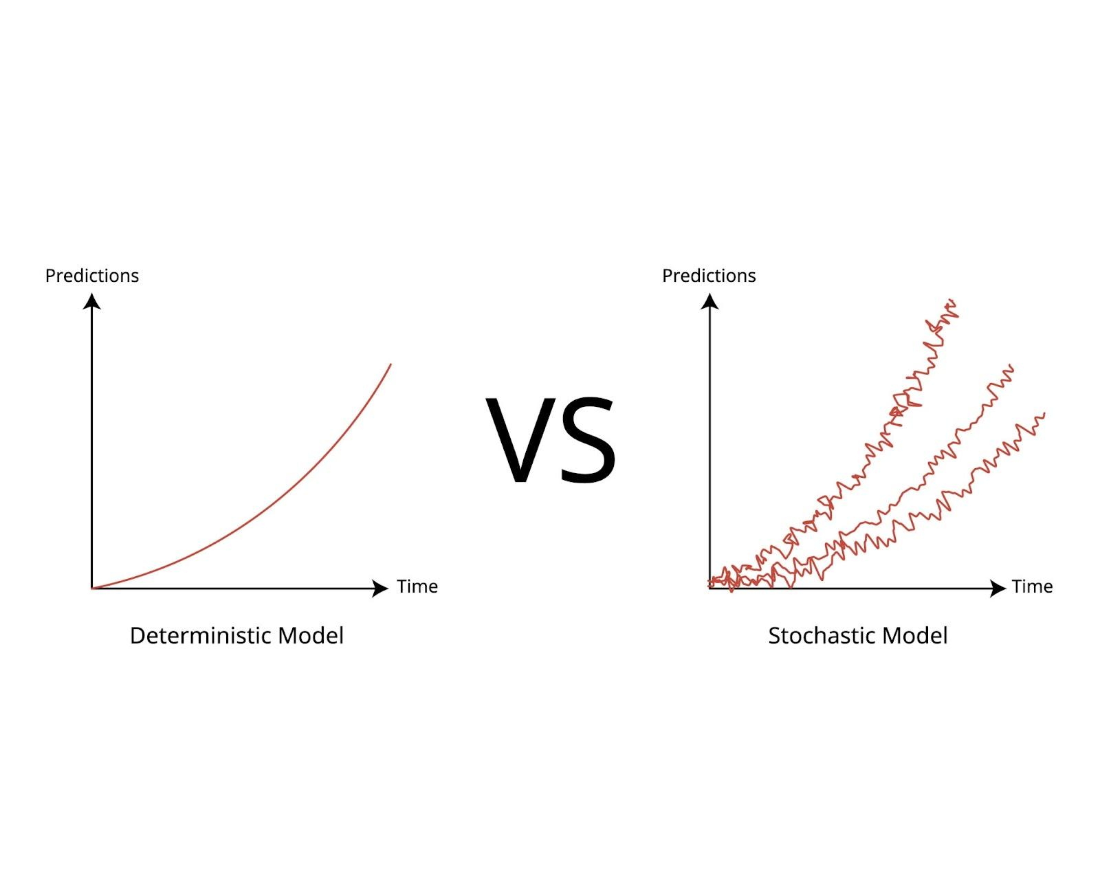
2.5 Applications & Impact
By the 2010s, Machine Learning had become the "combustion engine" of the modern software industry, powering applications that defined the decade.
2.5.1 The Recommendation Economy
The most visible impact is in content curation. Algorithms like Collaborative Filtering allow platforms (Netflix, Spotify, Amazon) to predict user preferences by analyzing the behavior of similar users. This has fundamentally shifted the economy from "search" (active user intent) to "discovery" (passive algorithmic feed).
2.5.2 Predictive Analytics in Industry
- Finance: ML algorithms execute high-frequency trades in microseconds and assess credit risk by analyzing thousands of variables, including non-traditional data like social media activity.
- Healthcare: Systems can now predict patient readmission rates and assist in diagnostics. For example, ML models for detecting diabetic retinopathy from retinal scans have matched or exceeded the performance of human ophthalmologists.
2.6 Limitations That Led to the Next Paradigm
Despite its successes, "Traditional" Machine Learning (using algorithms like SVMs, Random Forests, and Logistic Regression) hit a performance ceiling that necessitated the rise of Deep Learning.

- The Feature Engineering Bottleneck
This was the most significant limitation. Traditional ML algorithms cannot understand raw data (like pixels or audio waves). A human expert must manually extract "features" first.
- Example: To detect a car, a human engineer had to write code to define "wheels" (circular shapes), "windows" (rectangular shapes), and "edges."
This process was slow, expensive, and brittle. If the lighting changed or the car was partially hidden, the manual features often failed.

- The Curse of Dimensionality
As data became more complex (e.g., high-resolution video), the number of variables (dimensions) became too vast for traditional statistical models to handle. The computational cost grew exponentially, and the models struggled to distinguish meaningful signals from noise in high-dimensional space.

- Performance Plateau
Traditional ML algorithms exhibit a "performance plateau." After a certain amount of data, feeding the model more data does not improve its accuracy. They lack the capacity to absorb the massive scale of Big Data.

This inability to automatically learn features from raw data and the plateauing performance on large datasets set the stage for the resurgence of Neural Networks and the era of Deep Learning.

3. Deep Learning (DL)

3.1 Introduction to Deep Learning
Deep Learning (DL) is a subfield of Machine Learning that focuses on learning data representations using artificial neural networks with multiple hidden layers. Its design is inspired by that of the human brain. The human brain learns by passing signals through interconnected neurons, where stronger connections have more influence on the final decision. Similarly, deep learning uses artificial neurons connected by weighted links, and it “learns” by adjusting these weights based on errors.
Unlike traditional machine learning methods that rely heavily on manually engineered features, deep learning models automatically extract meaningful features from raw data. This ability has made deep learning one of the most influential technologies in modern artificial intelligence, driving advancements in fields such as image recognition, speech processing, natural language processing, and autonomous systems.

3.2 Need and the rise of DL
Deep learning emerged to overcome the increasing limitations of traditional machine learning approaches. Earlier machine learning models performed reasonably well on structured and low-dimensional data but struggled with complex, unstructured data such as images, videos, and audio. These models required a lot of human effort for feature extraction, which was time-consuming and often ineffective for large-scale problems.
The availability of massive datasets, increased computational power (especially GPUs), and improvements in neural network training techniques allowed researchers to build deeper and more powerful models. As a result, deep learning emerged as a solution that could scale efficiently with data size and complexity.

3.3 Objectives of DL
Deep learning was developed to address several challenges including:
- Automatic feature extraction from raw data
- Handling high-dimensional and unstructured data
- Improving accuracy for complex real-world tasks
- Reducing dependency on domain-specific human expertise
By learning hierarchical representations, deep learning models can identify low-level features (such as edges in images) and gradually combine them into higher-level concepts (such as objects or faces), making them effective for perception-based tasks.

3.4 Historical Background
The concept of deep learning can be traced back to artificial neural networks, proposed in the 1950s, inspired by biological neurons. Early models, such as the perceptron, were promising but were limited by computational resources and the lack of large datasets. This led to periods of reduced interest known as AI winters.

The resurgence of interest in deep learning began in the early 2000s, driven by improved training algorithms such as backpropagation and the use of graphical processing units (GPUs). A major milestone occurred in 2012 when deep convolutional neural networks significantly outperformed traditional methods in image classification competitions. Since then, deep learning has become the dominant approach in many AI applications.

3.6 Architecture of Deep Learning Models
Deep learning models are based on artificial neural networks (ANNs) with multiple layers.

3.6.1 Key Concepts
- Neurons: Mathematical units that apply weights and activation functions
- Layers: Input layer, multiple hidden layers, and output layer
- Activation Functions: Introduce non-linearity (e.g., ReLU, sigmoid)
- Loss Function: Measures prediction error
- Backpropagation: Adjusts weights to minimize loss
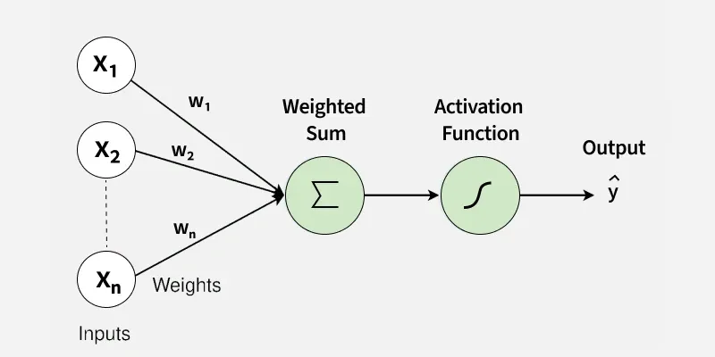

3.6.2 Working Principle
- Input data is fed into the neural network
- Each layer transforms the data using weights and activation functions
- The output is compared with the actual value using a loss function
- Errors are propagated backward to update weights
- The process repeats until optimal performance is achieved
This type of learning allows deep networks to model highly complex patterns that other models cannot.
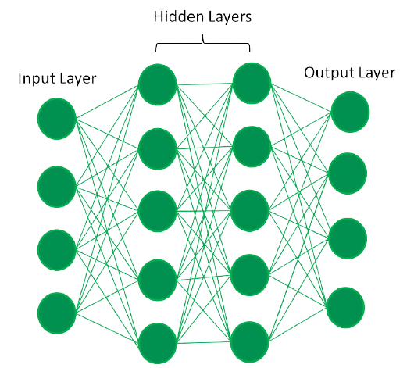

3.7 Applications of Deep Learning
Deep learning has transformed many industries:
- Computer Vision: Face recognition, object detection, medical imaging
- Natural Language Processing: Language translation, chatbots, sentiment analysis
- Speech Recognition: Voice assistants and speech-to-text systems
- Healthcare: Disease diagnosis, medical image analysis
- Autonomous Systems: Self-driving cars and robotics
These applications demonstrate the significant impact of deep learning, making it a core technology behind many intelligent systems today.

3.8 Limitations of DL – Moving towards Gen AI
Despite its success, deep learning has limitations:
- Requires very large labeled datasets
- High computational and energy costs
- Lack of interpretability (“black-box” nature)
- Susceptible to bias in training data
These challenges limit its deployment in domains where transparency, efficiency, and fairness are important.
The inability of deep learning models to generate truly novel content, reason properly, or explain their decisions led to the development of Generative AI. While deep learning focuses on recognition and prediction, generative models aim to create new data such as text, images, and music. Thus, the limitations of deep learning directly impacted the transition toward more creative AI systems.
Deep learning represents a major advancement in the evolution of artificial intelligence. By enabling automatic feature learning from raw data, it solved many problems faced by traditional machine learning approaches. However, its high resource demands and lack of explainability pushed the need for newer paradigms. Understanding deep learning is important, as it forms the foundation for modern AI and many emerging technologies.

4. Gen-AI (Generative AI)

4.1 Introduction – From prediction to creation

Classical AI, Machine Learning, and even Deep Learning systems are designed to analyze input data and produce a fixed or bounded output, such as a class label, probability score, or numerical prediction, making them focused on prediction rather than creation.

Deep Learning models, in particular, operate by learning the conditional probability:
P(y|x) – the probability of an output label y given an input x

For eg. A CNN can classify an image as a “cat” by computing probabilities over possible labels. However, despite their success, such models remain discriminative in nature: they recognize, classify, or predict, but do not create.

Generative AI represents a fundamental shift in this paradigm. Instead of learning how to map inputs to labels, Generative AI learns the structure of the data itself, modeled as:
P(x) – the probability distribution of the data

By learning how data is distributed, Generative AI systems can generate new, diverse, and realistic data samples, such as text, images, audio, or video.

4.2 Why did Gen-AI come into existence? - Limitations of DL

Despite its effectiveness, Deep Learning exhibits several limitations that motivated the development of Generative AI:
- Discriminative nature: DL models focus on classification and prediction, not generation.
- Fixed output space: Outputs are bounded (labels, scores), lacking diversity.
- Inability to model full data distributions: DL does not learn how data itself is formed.
- High data dependency: Requires large labeled datasets.
- Task specificity: Models are typically trained for narrow tasks.

4.3 Historical Evolution of Gen AI
- 1966 – ELIZA
- One of the earliest conversational programs.
- Rule-based and relied on pattern matching rather than learning.
- Created the illusion of intelligence but did not generate novel content.
- Early 1990s – Rise of GPUs
- 3D graphics cards developed for video games enabled massive parallel computation.
- GPUs were later applied to neural networks, making large-scale deep and generative models computationally feasible.
- 2006–2012 – Neural Network Revival
- Advances in backpropagation, availability of large datasets, and GPU acceleration.
- Neural networks became scalable for real-world applications.
- 2011 – Virtual Assistants
- Release of Siri with the iPhone 4S.
- Marked early large-scale human–AI interaction, but systems remained largely rule-based and non-generative.
- 2014 – Generative Adversarial Networks (GANs)
- Introduced adversarial training between a generator and discriminator.
- Enabled realistic image, audio, and video synthesis.
- Recognized as the first major breakthrough in deep generative modeling.
- 2017 – Transformer Architecture
- Introduced attention mechanisms to handle long-range dependencies.
- Formed the foundation for modern large language models (LLMs).
- 2020–2021 – Foundation Models
- Models trained on internet-scale datasets.
- Shift from task-specific systems to general-purpose generative models.
- 2022 – ChatGPT
- Release of ChatGPT, brought generative AI to the public and industrial use.
- Combined large language models with reinforcement learning from human feedback (RLHF).
- 2023–2025 – Acceleration Phase
- Rapid advances in reasoning, context length, multilingual capability, and multimodal generation (text, image, audio).
- Set the stage for the emergence of agentic and autonomous AI systems.

4.4 Working principle of Gen AI

- Data Representation  Raw data is first converted into numerical form so it can be processed by neural networks. This pre-processing is modality-specific:  - Text → tokens  - Images → patches  - Audio/Video→ spectrograms/frames  These representations are then mapped into a shared embedding (latent) space, where semantic and structural features of the data are captured in a compressed numerical form. | 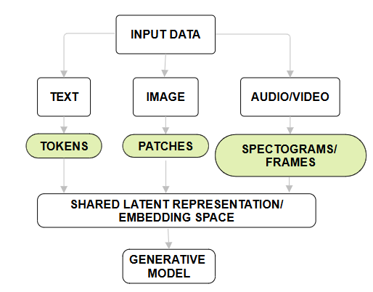  Fig 4.1 Modality specific encoding

- Neural Model Training  A deep neural network (commonly transformer-based or diffusion-based) is trained to understand statistical patterns within the data. Training typically involves:  - Predicting the next token (for text)  - Predicting missing or noisy components (for images/audio/video)  - Minimizing prediction error using backpropagation  Through exposure to large datasets, the model internalizes syntax, semantics, structure, and context.  - Probability Modeling  Instead of producing a single deterministic output, the model learns a probability distribution over the latent representations of data. This allows the model to estimate multiple plausible continuations or reconstructions rather than a fixed answer.  This probabilistic formulation enables:  - Multiple valid outputs  - Diversity in generation  - Creativity and variability  - Sampling & Generation  During inference, the model samples from the learned probability distribution in the latent space. Generation proceeds iteratively, where each generated element is fed back as input for the next step, until a complete output is produced. This process enables the generation of coherent long-form text, realistic images, audio, or videos from minimal input. | 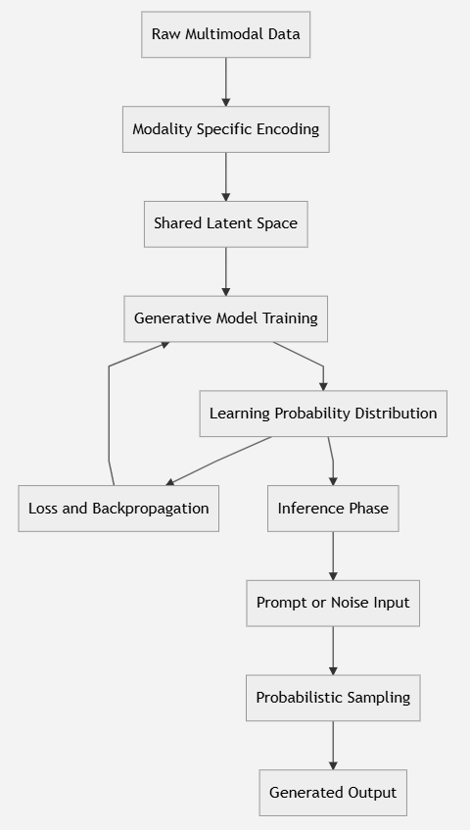  Fig 4.2 Working pipeline of Generative AI

4.5 Applications & Impact of Gen AI

4.5.1 Impact of Gen AI

- Productivity: Automates writing, coding, analysis
- Creativity: Lowers barrier to content creation
- Industry: Transforms education, media, healthcare
- Human–AI Interaction: AI becomes a collaborator to human effort and refinement

4.5.2 The current Landscape of Gen AI

Modality | Example Systems / Models | Maturity Level
Text | • GPT-5.1 – OpenAI’s latest multimodal LLM (2025)  • Claude Opus/Claude Sonnet 4.5 – Anthropic’s reasoning-focused generative models  • Gemini 3 / Gemini 3 Pro – Google DeepMind’s flagship multimodal family | Highly Mature
Image (Text-to-Image) | • Nano Banana / Nano Banana Pro (Gemini Image) – Google’s leading image models (built on Gemini 3 Pro)  • Imagen 4 – Google DeepMind text-to-image model | Highly Mature
Video (Text-to-Video) | • Veo 3.1 – Google text-to-video model, including synchronized audio generation  • LTX-2 – Lightricks video generation model (4K frames) | Emerging
Audio (Speech / Music) | • Suno v5 – Studio-grade music and audio generation (improved fidelity)  • Stable Audio Open – Audio generation by Stability AI (music, sound effects) | Emerging
Multimodal (Joint Text + Image + Audio / Video) | • Gemini 3 Pro  • Qwen2.5-Omni / Qwen3  • Unified-IO 2 (research) – Experimental multimodal generation in research community | Rapidly Evolving

4.6 Limitations of Gen AI – Moving towards Agentic AI
Generative AI systems are quite effective at creating text, images, audio, and video, but they are fundamentally reactive. They operate in response to prompts and lack intrinsic goals, long-term planning, and autonomous decision-making. They also do not maintain persistent memory across interactions and may generate hallucinated or inconsistent outputs due to their probabilistic nature.
These constraints limit Generative AI to content generation rather than action-oriented intelligence.
To address this, Agentic AI extends generative models with planning, tool usage, memory, and multi-step reasoning capabilities, enabling AI systems to act autonomously toward defined objectives.

5. Agentic AI

5.1 Introduction to Agentic AI
Agentic AI, also known as Agent AI, emerged prominently in 2023–2025 as the next evolution beyond generative AI (GenAI), building upon large language models (LLMs) to create autonomous systems capable of reasoning, planning, and executing complex tasks with minimal human intervention.

These systems represent a paradigm shift from passive text generation to active, goal-directed behavior, enabling AI to interact with environments, use tools, and adapt through feedback loops. A key definition: "An artificial intelligence (AI) agent is a software program that can interact with its environment, collect data, and use that data to perform self-directed tasks that meet predetermined goals," distinguishing it from traditional software by its autonomy and rationality. While GenAI excels at content creation, Agentic AI remedies its limitations by introducing planning, memory, and tool integration for real-world task execution, marking the "age of reasoning" in AI.

AI Agents are autonomous software entities capable of perceiving environments, making decisions, taking actions toward goals, and learning from experiences, representing a core paradigm in intelligent systems.

Defined as systems that "process data, make decisions, and adapt over time" with autonomy, they bridge symbolic and neural approaches, powering everything from chatbots to robotics.

5.2 Problems addressed by Agentic AI
Agentic AI addresses fundamental limitations of traditional and generative AI, enabling autonomous, goal-directed behavior in complex, dynamic environments.

- Lack of Autonomy and Proactivity in GenAI
Generative models like GPT excel at single-turn text completion but fail at multi-step tasks requiring planning, tool use, or adaptation. Agentic AI introduces perception-action loops and reflection to execute workflows independently (e.g., booking travel end-to-end vs. just suggesting steps).

- Statelessness and Poor Long-Horizon Reasoning
LLMs are memoryless per interaction, struggling with context retention over sequences. Agents maintain persistent memory (vector stores, graphs) and decompose long tasks into subtasks via hierarchical planning, mitigating "hallucination cascades."

​
- Inability to Interact with External Tools/World
Traditional AI lacks real-world interfaces; Agentic systems integrate APIs, databases, and code execution, allowing actions like querying weather, sending emails, or debugging code autonomously.

- Scalability and Efficiency in Complex Domains
Symbolic AI is rigid; pure neural networking is stochastic. Agentic hybrids balance reliability (symbolic planning) with adaptability (LLM creativity), solving robotics, finance, and enterprise problems where partial failures cascade.

5.3 Historical evolution
Agentic AI represents the culmination of decades of AI agent research, evolving from rigid rule-based systems to autonomous, reasoning entities powered by modern LLMs.
​
5.3.1 Classical Foundations (1950s–1980s): Birth of AI Agents
AI agents originated with symbolic AI in the 1950s: Newell and Simon's Logic Theorist (1956) as an early "reasoning agent," followed by Shakey the Robot (1966–1972), the first mobile agent using perception-planning-action cycles. The 1970s–1980s brought expert systems (e.g., MYCIN for medical diagnosis, 1976), rule-based agents with knowledge bases, establishing core agent principles like autonomy and goal-orientation.
​
5.3.2 Reactive and Learning Agents (1990s–2010s): Reinforcement Learning Era
The 1990s introduced reactive agents (Brooks' subsumption architecture, 1986) for real-time robotics, emphasizing behavior hierarchies over central planning. Reinforcement learning (RL) agents emerged: TD-Gammon (1992) for backgammon, AlphaGo (2016) mastering Go via self-play, blending neural networks with Monte Carlo Tree Search. Multi-agent systems (MAS) gained traction for coordination (e.g., robotic swarms).
​
5.3.3 LLM-Driven Revival (2020s): Agentic AI Emergence
LLM breakthroughs (GPT-3, 2020; ChatGPT, 2022) revived agents by enabling natural language reasoning. Early prototypes like Auto-GPT (March 2023) and BabyAGI demonstrated LLM-chaining for autonomy, marking Agentic AI's birth. Frameworks (LangChain, LlamaIndex, 2023) standardized tool-use and memory, evolving to hierarchical/multi-agent systems by 2024.
​
5.3.4 Hybrid Maturation (2024–2026): Agentic AI Today
Post-2024 surveys document 90+ studies on neuro-symbolic hybrids, combining symbolic planning's reliability with neural adaptability (e.g., AWS Bedrock Agents for enterprise). Milestones: ReAct framework (2022) for reasoning-acting loops; enterprise deployments accelerating scientific discovery and automation. Agentic AI now encompasses self-evolving agents, closing the loop from classical AI agents to scalable, LLM-empowered systems.

5.4 Core concepts & Working principle

5.4.1 ReAct Loop
Working Principle is the ReAct Loop, given as follows:
- Observe/Perceive: Gather current state (e.g., "user query: book flight").
- Reason/Plan: LLM generates thought ("search flights → select best → book").
- Act: Execute tool (call flight API).
- Observe Result: Parse tool output (e.g., available flights).
- Reflect: Evaluate ("this option fits budget") and iterate until goal met.
This loop handles long-horizon tasks, with memory preventing repetition.

5.4.2 Agent Architecture
AI Agents follow a perceive-reason-act-learn cycle: perceive via sensors/APIs, reason using LLMs/planners, act through tools/executors, and learn via memory/reflection. Core components: Perception (data acquisition), Decision Engine (LLM/RL for planning), Action Module (tool integration), Memory (short/long-term), and Reflection (self-critique).

5.5 Applications & Impact
Some of the key applications are as follows:

- Healthcare-
Multi-Agent Diagnostics: Agents coordinate for holistic patient analysis (e.g., one agent reviews vitals, another cross-references research, a third recommends treatments).
​Personalized Care: Adaptive agents monitor chronic conditions, adjusting plans via wearables and EHR integration.
- Finance and Trading-
Autonomous Trading: Agents analyze markets, execute trades, and hedge risks in real-time using APIs (e.g., Amazon Bedrock for portfolio optimization).
Fraud Detection: Proactive agents flag anomalies and auto-remediate.
- ​Robotics and Manufacturing-
Warehouse Automation: Agents plan robot paths, coordinate fleets, and optimize inventory (e.g., Flipkart/Amazon logistics).
Adaptive Navigation: Model-based agents handle dynamic obstacles.
- Software Development and Enterprise-
Code Agents: Auto-generate, debug, and refactor code (e.g., Devin AI, AWS CodeWhisperer agents).
Workflow Orchestration: Multi-agent systems for IT ops, customer service (e.g., Zendesk agents).
- Scientific Research
Discovery Acceleration: Agents hypothesize experiments, analyze data, iterate (e.g., AlphaFold agents for protein design).

Measurable Impacts are:
- Productivity: 40–66% time savings in knowledge work via task delegation (PwC survey); developers report 55% faster coding.​
- Cost Efficiency: Reduced human oversight in routine tasks; enterprise agents cut ops costs by 30–50%.
- Scalability: Multi-agent systems handle parallel workloads, enabling emergent intelligence (e.g., debate-based reasoning).​
- Decision Quality: Real-time data fusion improves accuracy in uncertain environments (e.g., 20–30% better trading returns).​
- Innovation: Accelerates R&D cycles (e.g., months to days in drug discovery).

5.6 Paradigms and Challenges
- Symbolic paradigm: Rigid, lacks generalization in noisy data; high engineering cost.
- Neural/LLM paradigm: Hallucinations, poor long-term planning, high compute, brittleness to prompt changes.
- Cross-cutting: governance (bias/escalation risks), privacy (tool/data access), evaluation gaps (beyond benchmarks), and safety in open environments.

Hybrids aim to mitigate, but scalability and ethical alignment remain open challenges.

6. Comparative Analysis and Synthesis

6.1 Hierarchy of AI Paradigms

Artificial Intelligence paradigms form a hierarchical progression, where each newer paradigm builds upon and extends the capabilities of the previous one rather than replacing it.
Hierarchy:
Artificial Intelligence (AI) – umbrella concept
Machine Learning (ML) – data-driven learning
Deep Learning (DL) – multi-layer neural representation learning
Generative AI (Gen AI) – probabilistic data generation
Agentic AI – autonomous, goal-directed action systems
This hierarchy reflects increasing data dependence, model complexity, autonomy, and abstraction, moving from rule execution toward reasoning and action.

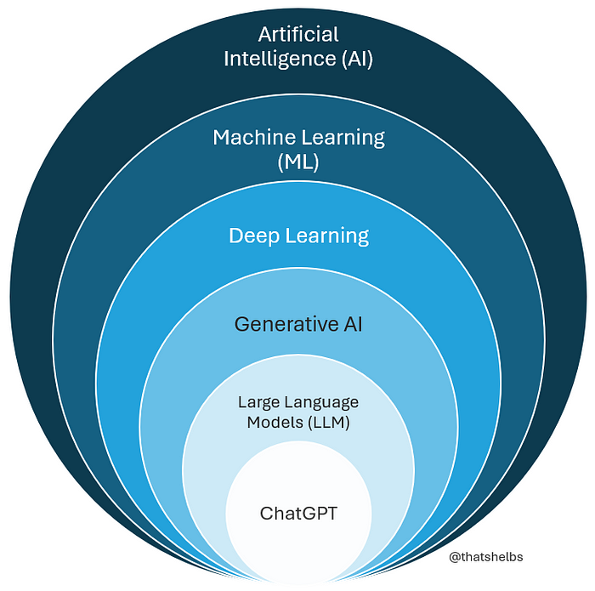

Add venn diagram like this but with agentic ai inside gen ai.

6.2 Fundamental-Level Comparison

At the most fundamental level, the paradigms differ in what they learn and how they operate:

- AI (Symbolic): Learns rules written by humans
- ML: Learns patterns from data
- DL: Learns representations from raw data
- Gen AI: Learns data distributions
- Agentic AI: Learns how to achieve goals through planning and action

This progression marks a shift:
From explicit knowledge → statistical inference → representation learning → creation → autonomy

6.3 Accuracy vs Data Availability (ML vs DL)

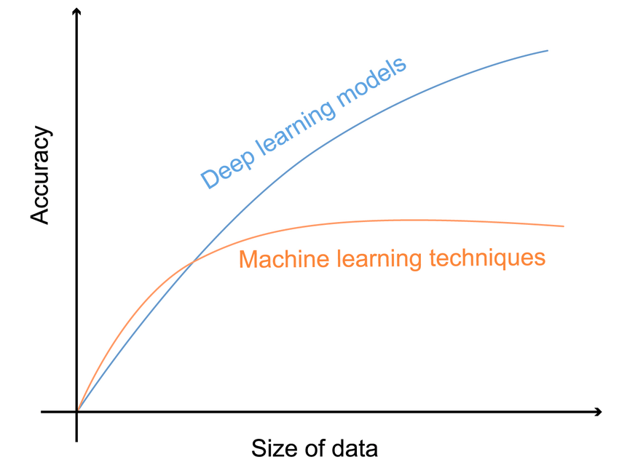

Graph 6.1 Model accuracy vs Amount of Training Data
- Behavior:
  - At low data volumes, traditional ML models outperform DL due to simpler structure, lower variance, and less overfitting.
  - As data volume increases, ML accuracy plateaus due to limited representational capacity.
  - DL accuracy continues to improve, eventually surpassing ML because it can absorb large-scale data, automatically learns hierarchical features.
- Key Insight:
Deep Learning is data-hungry but scalable, while traditional ML is efficient but capacity-limited.

6.4 Rule Complexity vs Data Capacity

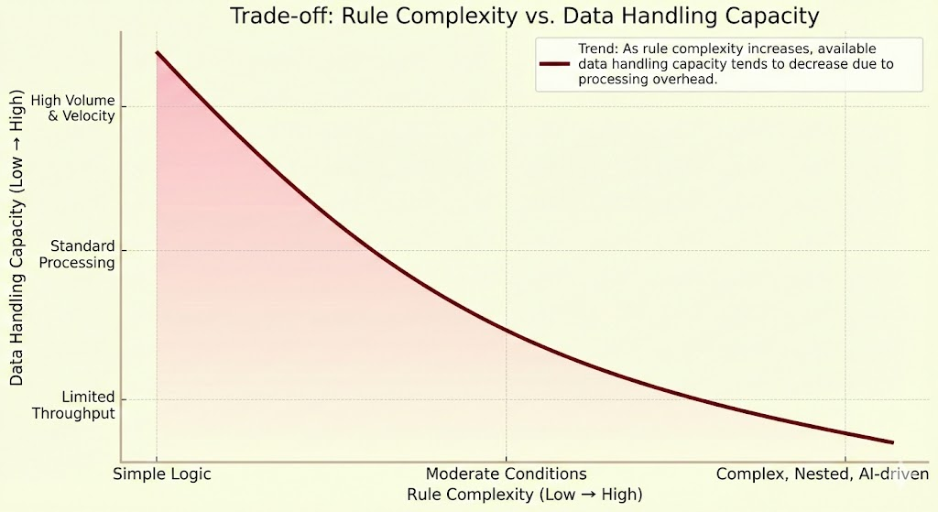
Graph 6.2 Rule Complexity vs Data Handling Capacity

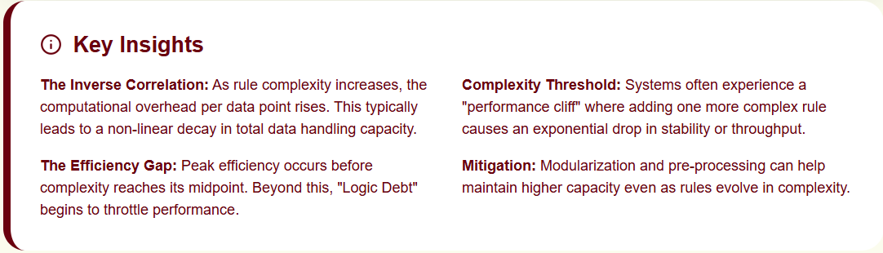

Segments:
- Humans – High reasoning, limited scalability
- Traditional Programming – Explicit rules, low data tolerance
- Machine Learning – Fewer rules, higher data dependence
- Deep Learning – Minimal rules, massive data absorption
This graph shows the trade-off between rules and data:
- As rule complexity decreases, data dependence increases.
- DL systems replace rules almost entirely with learned representations.

6.5 Interpretability and the “Black Box” Problem

- Symbolic AI: Fully interpretable (explicit rules)
- Traditional ML: Mostly interpretable (linear models, trees)
- Deep Learning: Largely non-interpretable (“black box”)
- Gen AI: Probabilistic and opaque
- Agentic AI: Most complex, combining multiple opaque components
This creates a trade-off between:
Performance vs Explainability
Which is critical in domains like healthcare, law, and governance.
6.6 Use-Case-Oriented Comparison

Task Type | Best Paradigm
Rule-based reasoning | AI
Prediction on structured data | ML
Image, speech, NLP | DL
Content creation | Gen AI
Autonomous task execution | Agentic AI

No single paradigm is universally superior; suitability depends on task complexity, data availability, and autonomy requirements.

6.7 Summarised Comparisons

Aspect | AI | ML | DL | Gen AI | Agentic AI
Core Idea | Rules | Patterns | Representations | Data generation | Goal-directed action
Data Dependency | Low | Medium | High | Very High | Very High
Feature Learning | Manual | Manual | Automatic | Automatic | Automatic
Interpretability | High | Medium | Low | Low | Very Low
Creativity | None | None | None | High | High
Autonomy | None | Low | Low | Low | High
Tool Interaction | No | No | No | No | Yes
Typical Output | Decisions | Predictions | Predictions | New data | Actions + decisions

6.8 Conclusion

This comparative study demonstrates that Artificial Intelligence is not a single technology but an evolving spectrum of paradigms, each addressing the limitations of its predecessor. Symbolic AI laid the conceptual foundation but failed to scale. Machine Learning introduced adaptability through data, while Deep Learning enabled representation learning at unprecedented scale. Generative AI expanded intelligence from prediction to creation, and Agentic AI further extended it toward autonomous reasoning and action.

Rather than competing approaches, these paradigms form a layered ecosystem. Understanding their hierarchy, trade-offs, and application boundaries is essential for designing intelligent systems that are not only powerful but also reliable, interpretable, and aligned with real-world objectives.

6.9 References

- https://arxiv.org/abs/2504.18875
- https://arxiv.org/abs/2510.25445
- https://openreview.net/forum?id=TyCYakX9BD
- https://en.wikipedia.org/wiki/Lighthill_report
- https://gwern.net/doc/cs/hardware/2002-roland-strategiccomputing-darpaandthequestformachineintelligence19831993.pdf
- https://the-learning-agency.com/insights/lessons-on-arpa-failures/
- https://telefonicatech.com/en/blog/mycin-the-beginning-of-artificial-intelligence-in-medicine
- https://news.ycombinator.com/item?id=9315185
- https://medium.com/@froger_mcs/moravecs-paradox-c79bf638103f

